ABINAV S T  
230701007

EXP NO:3a **Shell Script –Reverse the Digit**

PROGRAM:

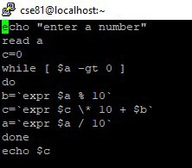

OUTPUT

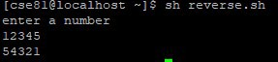

EXP NO:3b **Fibbonacci Series**

PROGRAM:

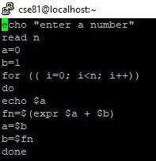

OUTPUT

